STEP 10

**Figure 1.** Figure 1 shows us a single snippet from Channel 6. The total snippet window is 1.5 ms, starting at 0.4 and ending at 1.1ms on the x axis. The snippet amplitude, in millivolts, is displayed on the y axis.

STEP 11

Figure 2. Minimum and Maximum values are plotted on the x and y axis. It appears as though there are more dense areas closer to under 4 mV (maximum) and above -4 mV (minimum). Snippet density is shown in this figure.

STEP 12: After PCA was calculated and variance examined: number of components to explain 95.00% of variance was determined to be 8. However, these slowly start to show less difference in the amount of data. I think further inspection of the clustering is required.

STEP 13

**Figure 3.** Significant Components from Channel 7 were selected. Component 1, 2, and 3 can be seen. The time is shown in milliseconds and amplitude in millivolts.

STEP 16 and 17

**Figure 4.** PCA analysis was done using clusters one and two from channel 7. The components were then separated.Distinct groups can be identified here and were subsequently separated. These were separated due to having different peaks and hyperpolarization patterns. Unclustered and clustered waveforms can be seen here.

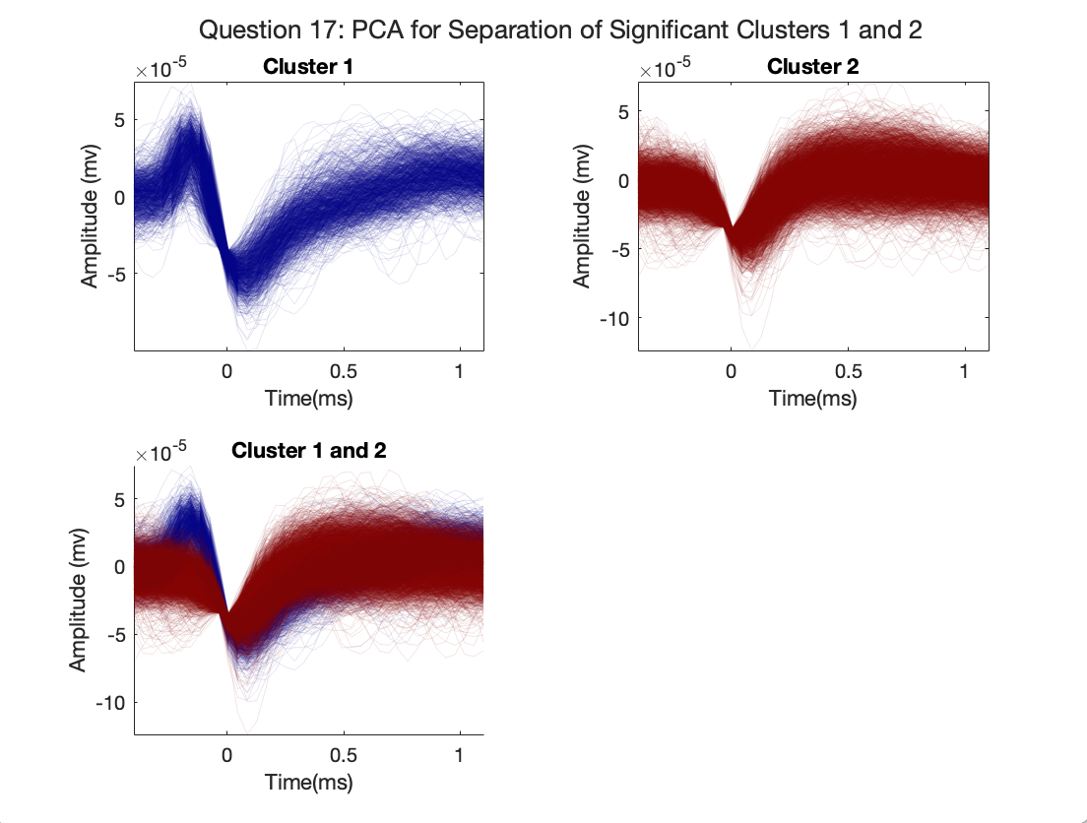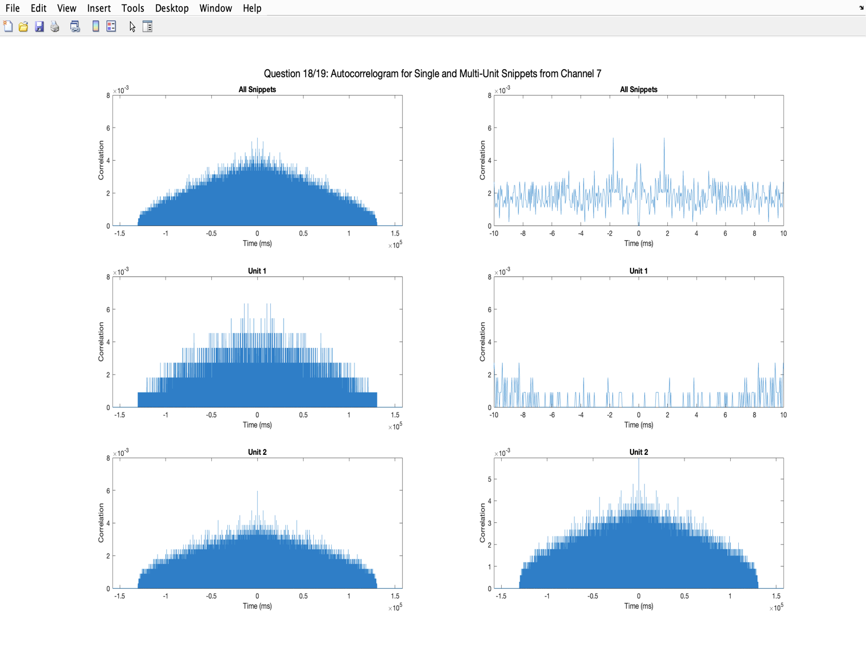

**Figure 5.** Autocorrelelogram and histogram data is shown here. Clearly, a single and multiunit neuron’s data is shown. The autocorreologram of Unit 1 (middle right) corresponds to a single unit, while Unit 2 (lower right) shows multiunit. This can be observed due to spiking pattern, which provides valuable information regarding hyperpolarization of neurons.

**Accompanying questions:**



20. **What is the difference between intra-cellular and extra-cellular electrophysiological recordings? Sketch a trace of their temporal shapes.**



*Intracellular*

-Intracellular recordings are collected by using a microelectrode stuck into only a single neuron. This electrode is going to is measured membrane potential and actually punctures the membrane. The negative phase of the intracellular action potential going to come from after-hyperpolarization. It provides a lot of information about one single neuron, and you can more accurately know information about just that one neuron. After taking the electrode away, the neuron is gone and you cannot study that same one again because you had punctured a hole in it.

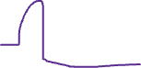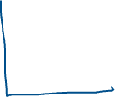

*Extracellular*

-Extracellular recordings are collected from electrodes placed outside the neuron in extracellular space. These collect information on the electrical signals from many neurons that are close to the electrode. Since it collects information this way, it is less specific and is combined data from many neurons that are close to the electrode. This can be helpful for collecting data on spikes. After removing the electrode, the neuron is still there and you can study or monitor neural activity again because you didn’t cause the cell or cells to die.

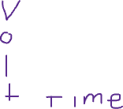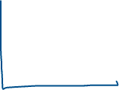

**21. How can you help isolate spikes prior to data acquisition? How would you isolate individual spikes from the snippet data already acquired?**

Isolating spikes is important when looking at EEG data and to do this you would need to perform some filtration and data preparation beforehand. There are many ways to isolate and sort individual spikes from snippet data that was already acquired. We can do this by spike sorting mathematically or with algorithm. Some of these approaches include using: K-Means or PCA. Then, cluster similar waveforms together. After that, you would need to filter using high or low bandpass to remove noise. Then, perform a technique like PCA to identify similar clusters. After that, manually inspect and adjust your waveforms.

**22. How could you use PCA analysis to determine whether there are there individual neurons that only respond to the visual stimulus?**

PCA could help identify and simplify the complex waveforms produced during visual stimulation. When we are clustering these simplified waveforms after filtered, you can spot patterns that might represent neurons reacting to the visual stimulus especially if they might align with the TRIG ON/TRIG OFF or moments the subject is shown these stimuli. You would examine the clusters to see patterns and relationships.

**23. How would you exclude snippets in a cluster that are weakly associated with the cluster?**

There are several methods to approach exclusion of snippets from a cluster that are not appropriate. I will briefly mention a few of them. One of these involves inspecting your clustering and then redefining parameters or recalculating to manually remove the snippets that are not required. You can set thresholds and make sure to exclude data below this threshold. When looking for components that are significant, you could look at eigenvalues and the variation each of those components explain. If this reveals that there is not significance in your chosen component, exclude it. Examining variance would be a good first step to determine strong or weak association in your snippet clusters. If you are familiar with your data, you could manually look at your PCA and then try to exclude data that does not fit into the clusters you defined.

**24. How does the autocorrelalogram help us discriminate single units? What criteria is usually used for this purpose?**

The autocorrelalogram is helpful because It can be useful during analysis of neural spike data. It might be able to help identify single units of isolated neurons from activity from many units. Whether there is a single unit or multiple units present can be identified using different benchmarks. It is important to keep in mind the refractory period of a neuron after firing an action potential. Since it happens after the neuron fires this means the neuron cannot fire during that time while the neuron hyperpolarizes. This concept is important for when we are examining single v multiunit data in an autocorrelelogram. When examining at a single unit’s autocorrelelogram there is no time lag around 0. This “spike” does not appear. Therefore, it is showing a clear refractory period. If there is, instead a spike around 0, or multiple unit activity, there will be signal happening very close to one another. Since there is no evident refractory period, it is likely the autocorrelogram reflects signal from many units. Also, in the autocorrelogram of a single unit, there is often a clear peak and a valley around it but multiunit, you may see activity that shows several different peaks since there is input from more than one neuron. Similarly, single units would show more even or regular spike patterns that have a relatively consistent spacing in time. This regularity is reflected in the autocorrelogram as regularly spaced peaks. If irregularity is observed, this might be representative of multiple unit input.

EXTRA CREDIT

See code for part 12-17 repeated for different channels. I did as many channels as I could before submission.

